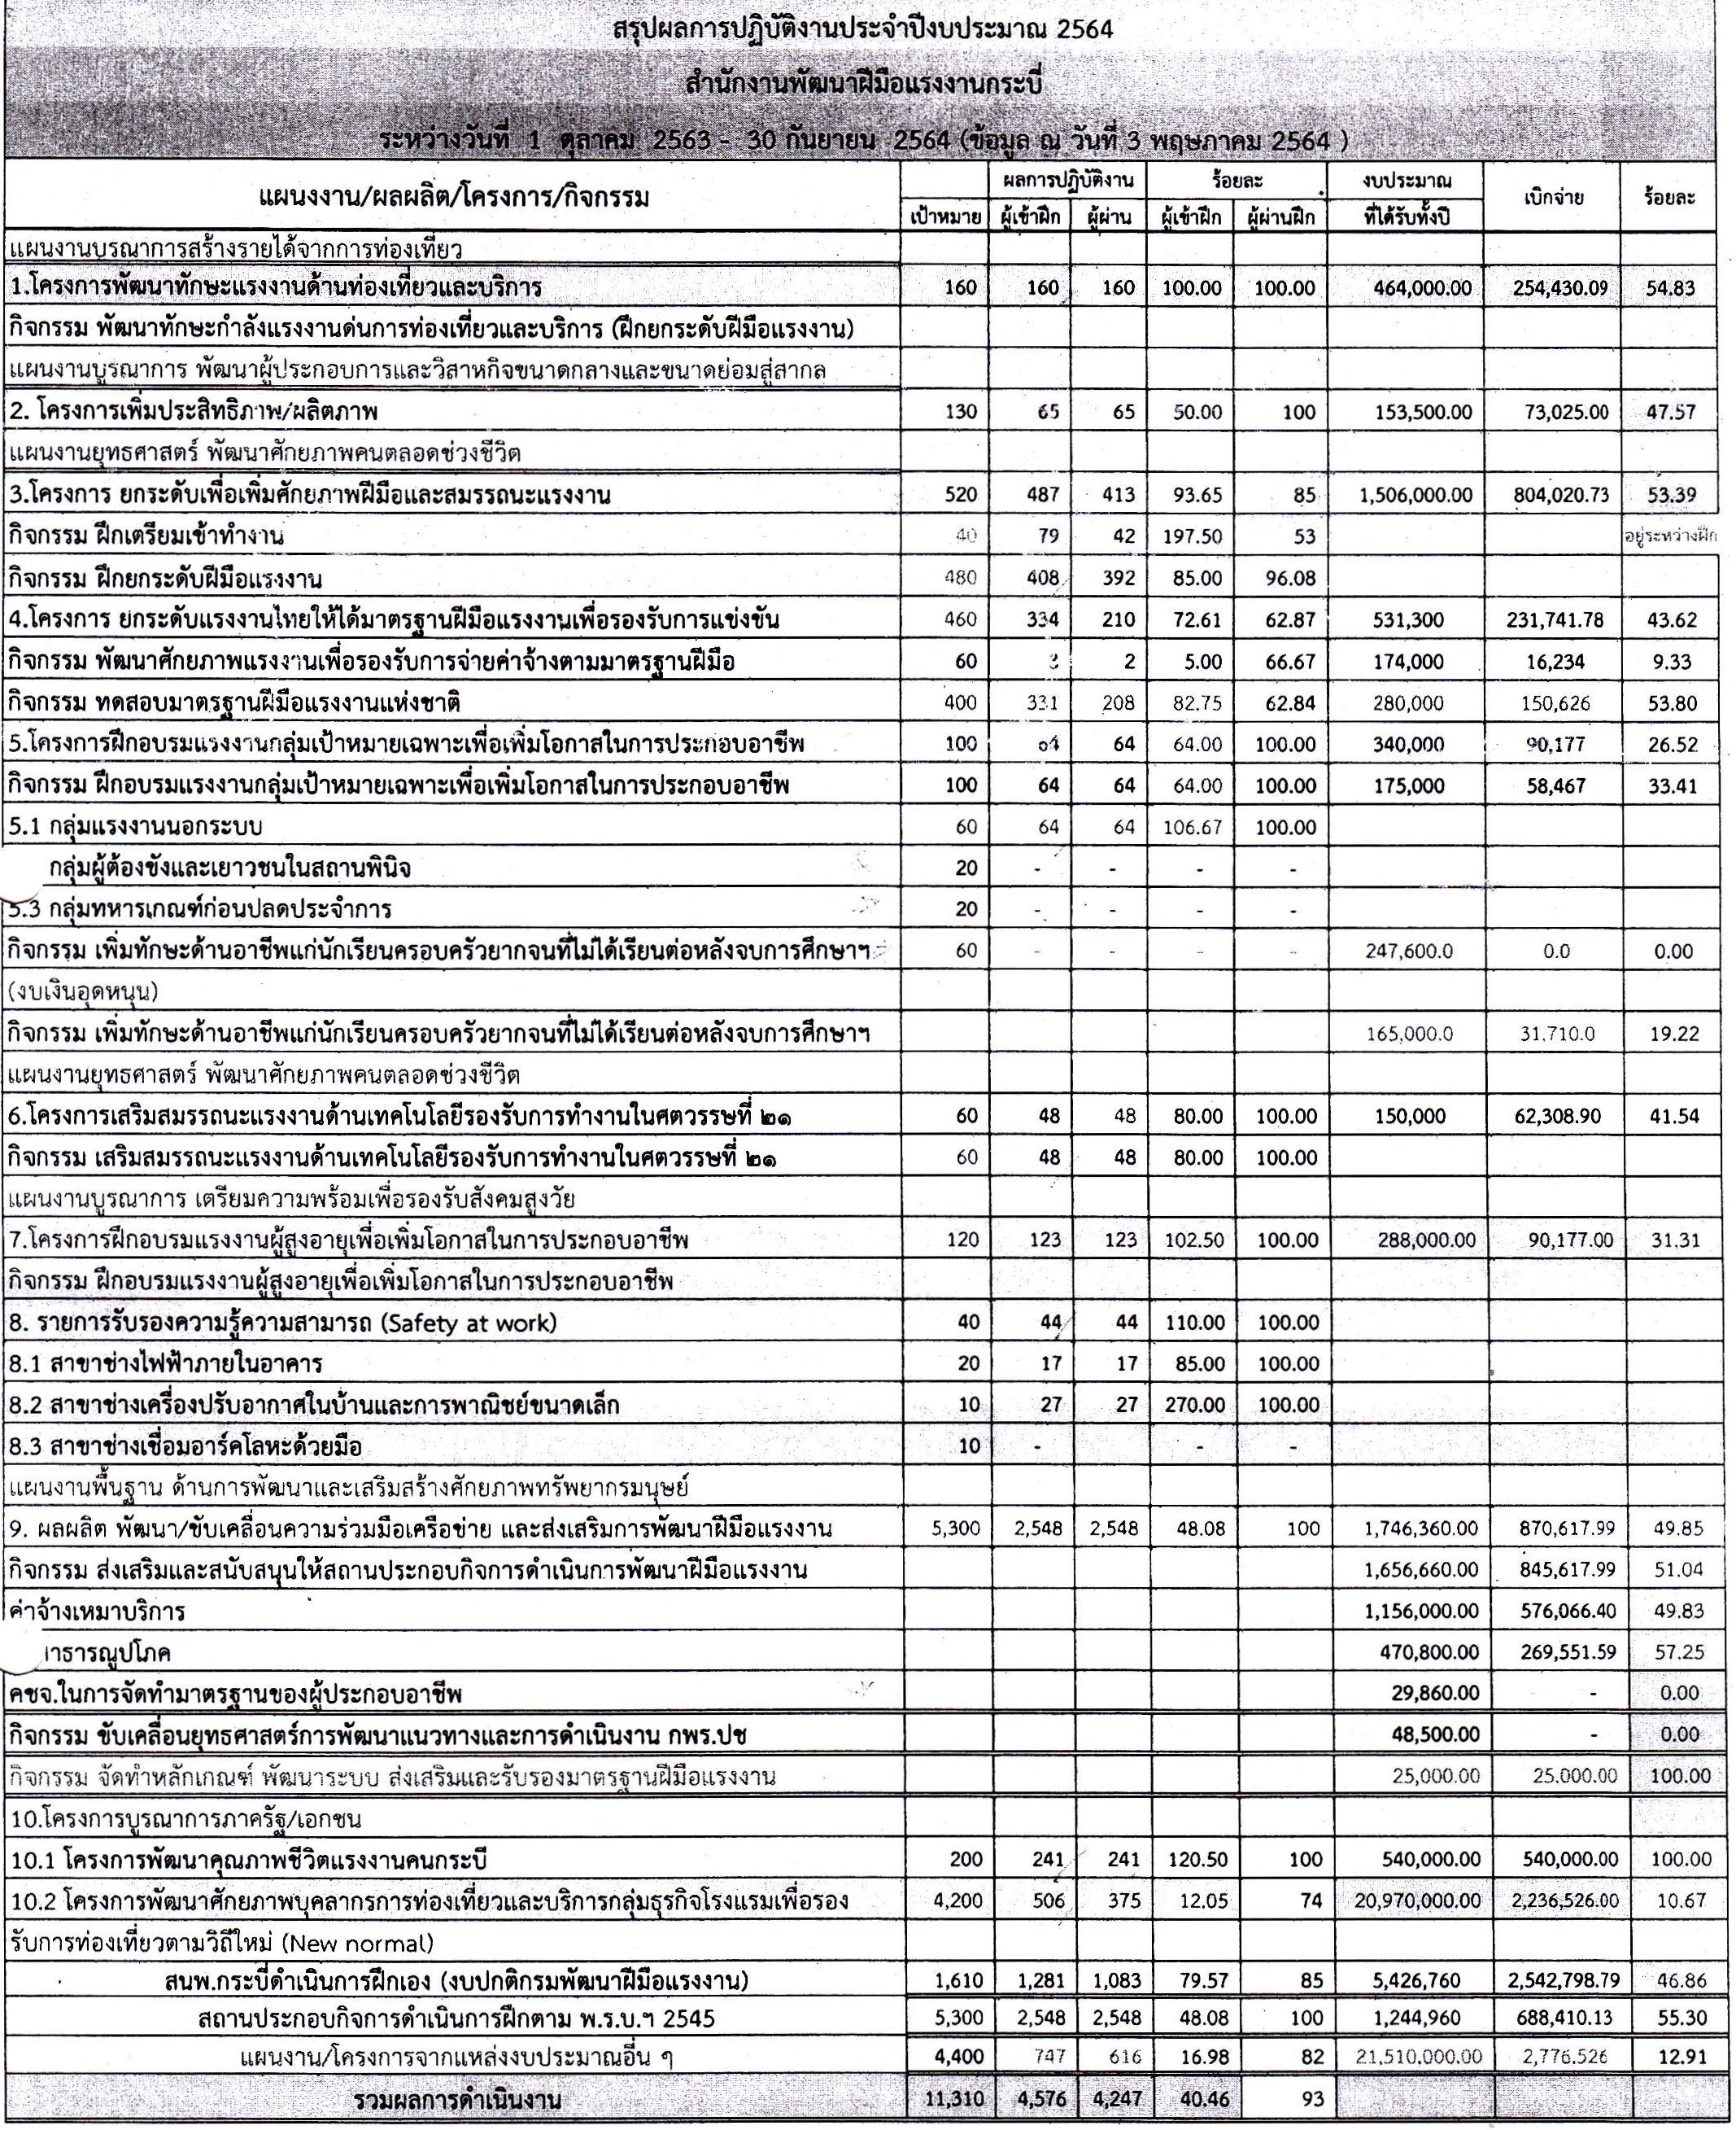

<fD\!111 N i111 Wfl'dll1fUJ
1"J\J1'UJlfltl... Wllllif u:t;J.m1nitUu'liljjEI 1-H1U

